**How to Install Roundcube Webmail on CentOS/RHEL 8/7**

[Aaron Kili](https://www.tecmint.com/author/aaronkili/)**Last Updated: February 18, 2021** Categories[Postfix Mail Server](https://www.tecmint.com/category/postfix-mail-server/) [26 Comments](https://www.tecmint.com/install-roundcube-webmail-on-centos-7/#comments)

**Roundcube** is a free and open-source, fully-featured web-based multilingual IMAP webmail software, with an application-like user interface that is fully functional and customizable, and uses the latest web standards. It is built using PHP and offers full functionality that you can expect from a modern email client.

**Roundcube Features:**

* It’s multilingual, supports over 70 languages.
* Supports a Find-as-you-type address book.
* Supports multiple sender identities.
* Offers sophisticated privacy protection.
* Has a full-featured address book with groups and LDAP connectors.
* Offers richtext/HTML message composing.
* Supports searching for messages and contacts.
* Supports Int. domain names (IDNA).
* Supports folder manipulation, shared folders, and ACL.
* Extensible using the Plug-in API.
* Provides spell checking functionality.
* Provides import/export functions.
* Has a plug-in API for flexible extensions and so much more.

**Recommended System Requirements:**

1. A [CentOS 8](https://www.tecmint.com/centos-8-installation/)/[RHEL 8](https://www.tecmint.com/installation-of-rhel-8/) or [CentOS 7](https://www.tecmint.com/centos-7-3-installation-guide/)/[RHEL 7](https://www.tecmint.com/red-hat-enterprise-linux-7-3-installation-guide/) Server with Minimal Install.
2. Apache or Nginx webserver
3. PHP and MySQL/MariaDB database
4. SMTP and IMAP server with IMAP4 rev1 support

For the scope of this article, we assume that you already have a running Postfix email server with virtual users, otherwise, follow our guides setup:

1. [Setting Up Postfix Mail Server and Dovecot with MariaDB – Part 1](https://www.tecmint.com/setup-postfix-mail-server-and-dovecot-with-mariadb-in-centos/)
2. [Configure Postfix and Dovecot Virtual Domain Users – Part 2](https://www.tecmint.com/configure-postfix-and-dovecot-with-virtual-domain-users-in-linux/)
3. [Install and Integrate ClamAV and SpamAssassin to Postfix Mail Server – Part 3](https://www.tecmint.com/integrate-clamav-and-spamassassin-to-protect-postfix-mails-from-viruses/)

**Testing Environment:**

For the purpose of this article, I will be installing **Roundcube Webmail** on a [Linode CentOS VPS](https://linode.gvw92c.net/tecmint" \t "_blank) with an Nginx web server, static IP address **192.168.0.100,** and hostname **mail.tecmint.com**.

**Step 1: Install Nginx, PHP-FPM, and MariaDB in CentOS 8/7**

**1.** First start by enabling [**EPEL**](https://www.tecmint.com/install-epel-repository-on-centos/) and **REMI** repositories and install **Nginx**, **PHP**, **PHP-FPM,** and **MariaDB** server on your **CentOS** system.

# yum install epel-release

# yum install http://rpms.remirepo.net/enterprise/remi-release-8.rpm [**CentOS/RHEL 8**]

# yum install http://rpms.remirepo.net/enterprise/remi-release-7.rpm [**CentOS/RHEL 7**]

# yum install yum-utils

# yum-config-manager --enable remi-php72

# yum install nginx php php-fpm php-mcrypt php-cli php-gd php-curl php-xml php-mysql php-mbstring php-pspell php-imagick mariadb-server

**2.** Once you have successfully installed all the packages, start the Nginx web server, enable it to auto-start at boot time and check if its up and running.

# systemctl start nginx

# systemctl enable nginx

# systemctl status nginx

**3.** Next, if you have a system firewall enabled, you need to open port **80** for external requests.

# firewall-cmd --permanent --add-port=80/tcp

# firewall-cmd --reload

**4.** Next, you need to configure **PHP-FPM** to work properly. Open the file **/etc/php.ini** using a command-line test editor.

# vim /etc/php.ini

Look for the directive ;cgi.fix\_pathinfo=1, uncomment it and set its value to **0**.

cgi.fix\_pathinfo=0

Also, uncomment the directive ;date.timezone and set its value to your **timezone**.

date.timezone = "Africa/Kampala"

Once you are done, save the file and exit.

**5.** Then start **PHP-FPM** service, enable it to auto-start at boot time, and check if it is up and running, as follows.

# systemctl start php-fpm

# systemctl enable php-fpm

# systemctl status php-fpm

**Step 2: Secure MariaDB Server and Create Roundecube Database**

**6.** Now start the MariaDB service using the following commands.

# systemctl start mariadb

# systemctl enable mariadb

# systemctl status mariadb

**7.** The default MariaDB installation is unsecure. You need to run the security script which comes with the binary package, to secure it. You will be asked to set a root password, remove anonymous users, disable root login remotely, and remove the test database.

# mysql\_secure\_installation

**8.** Now login to the MariaDB database, create a database for **Roundecube,** and grant the user to appropriate permissions on the database (remember to set a strong/secure password in a production environment).

# mysql -u root -p

**MariaDB [(none)]>** CREATE DATABASE roundcubemail /\*!40101 CHARACTER SET utf8 COLLATE utf8\_general\_ci \*/;

**MariaDB [(none)]>** CREATE USER 'roundcube'@'localhost' IDENTIFIED BY '=213@!#webL';

**MariaDB [(none)]>** GRANT ALL PRIVILEGES ON roundcubemail.\* TO 'roundcube'@'localhost';

**MariaDB [(none)]>** FLUSH PRIVILEGES;

**MariaDB [(none)]>** exit

**9.** Next, import the Roundcube table layout to the newly created database.

# cd /var/www/html/roundcubemail/

# mysql -u root -p roundcubemail < SQL/mysql.initial.sql

**Step 3: Download Roundcube Package**

**10.** In this step, download the latest stable version (**1.4.9** at the time of this writing) of Roundcube from the [download page](https://roundcube.net/download/) or use [wget command-line downloader](https://www.tecmint.com/10-wget-command-examples-in-linux/" \t "_blank) to get it, extract the TAR file, and upload the files into your web server document root.

# wget -c https://github.com/roundcube/roundcubemail/releases/download/1.4.9/roundcubemail-1.4.9-complete.tar.gz

# tar xzf roundcubemail-1.4.9-complete.tar.gz

# mv roundcubemail-1.4.9 /var/www/html/roundcubemail

**11.** Next, set the appropriate permissions on the Roundcube webroot files.

# chown -R nginx:nginx /var/www/html/roundcubemail

**Step 4: Configure Nginx Server Block For Roundcube Web Installer**

**12.** Now create an Nginx server block for the Roundcube under **/etc/nginx/conf.d/** (you can name the file the way you want but it should have a **.conf** extension).

# vim /etc/nginx/conf.d/mail.example.com.conf

Add the following configuration in the file.

server {

listen 80;

server\_name mail.example.com;

root /var/www/html/roundcubemail;

index index.php index.html;

#i# Logging

access\_log /var/log/nginx/mail.example.com\_access\_log;

error\_log /var/log/nginx/mail.example.com\_error\_log;

location / {

try\_files $uri $uri/ /index.php?q=$uri&$args;

}

location ~ ^/(README.md|INSTALL|LICENSE|CHANGELOG|UPGRADING)$ {

deny all;

}

location ~ ^/(config|temp|logs)/ {

deny all;

}

location ~ /\. {

deny all;

access\_log off;

log\_not\_found off;

}

location ~ \.php$ {

include /etc/nginx/fastcgi\_params;

#fastcgi\_pass 127.0.0.1:9000;

fastcgi\_pass unix:/var/run/php-fpm/php-fpm.sock;

fastcgi\_index index.php;

fastcgi\_param SCRIPT\_FILENAME $document\_root$fastcgi\_script\_name;

}

}

Save the file and close it.

**13.** Next, open the file **/etc/php-fpm.d/www.conf** to make a few changes to **PHP-FPM** web directive.

# vim /etc/php-fpm.d/www.conf

Change the user **apache** to **nginx** in the following variables.

user = nginx

group = nginx

Then comment out the line **listen = 127.0.0.1:9000** and set the listen variable to listen on a Unix socket set in the nginx server block file:

listen = /var/run/php-fpm/php-fpm.sock

Also, set the permissions for UNIX socket, uncomment and change the lines to:

listen.owner = nginx

listen.group = nginx

listen.mode = 0660

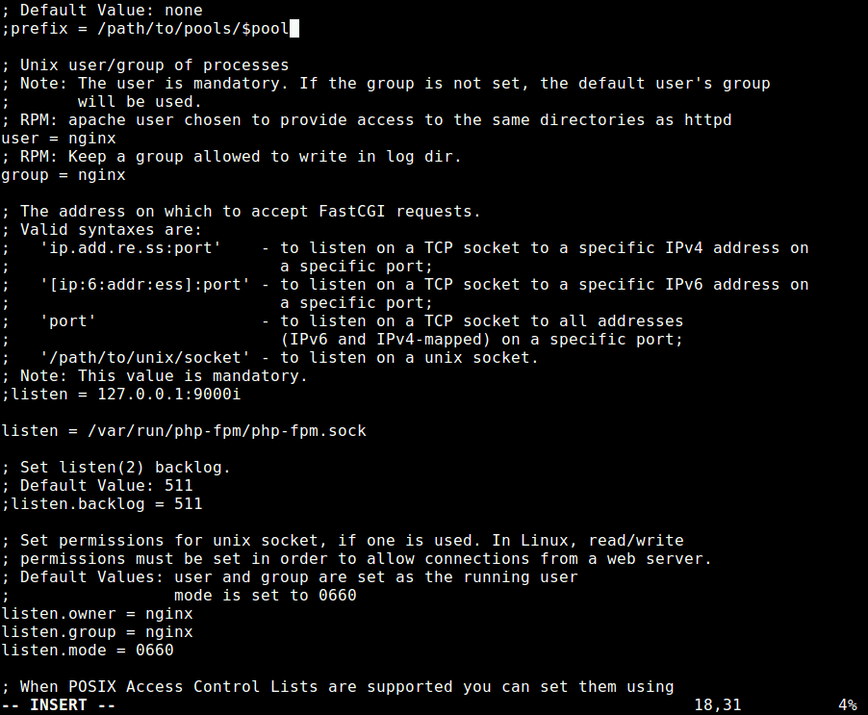Configure PHP-FPM

Once you are done, save the file and close it.

**14.** Then restart the **Nginx** and **PHP-FPM** services to apply the recent changes, as follows.

# systemctl restart nginx php-fpm

**Step 5: Access Roundcube Web UI**

**15.** Before you start the install wizard, to avoid any session errors, set the appropriate permissions on the directory **/var/lib/php/session/**. The default group owner is **apache**, change it to **nginx** as shown.

# ls -ld /var/lib/php/session/

# chown :nginx /var/lib/php/session/

# ls -ld /var/lib/php/session/

**16.** Now open a browser and use the address http://mail.example.com/installer (replace domain with the server name you set while creating an Nginx server block for Roundcube) to access the web installer. If all PHP versions, extensions, and **php.ini/.htaccess** settings are correct, you will see the following screenshot, click on **Next** to go to the configurations page.

http://mail.example.com/installer

OR

http://IP-address/installer

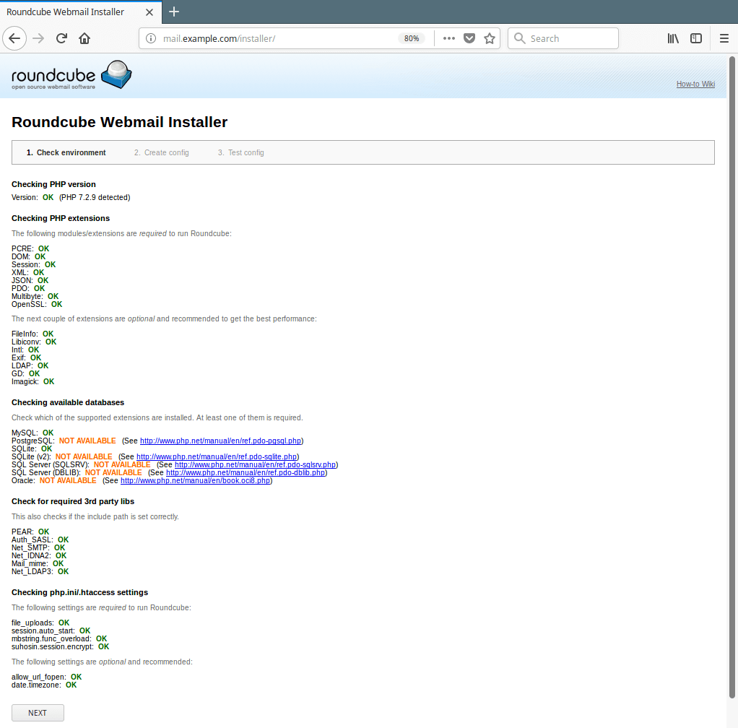Access Roundcube Webmail Installer